Pre-School Autumn Term: Theme...
My Bear and Me
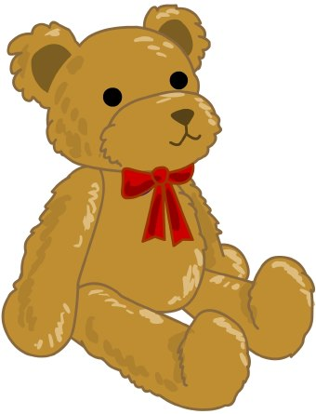

Prime Area: Personal, Social and Emotional development (PSED)
Self-registration, belonging to Rabbits Class/PS
Hand washing, personal hygiene, staying safe, healthy snacks
Pre-School routine including continuous provision/self-chosen activities
Learning names of staff and peers
ENTRUST – Units - Me and My School, Me and My Relationships
Expected behaviour – Be Ready, Show Respect, Stay Safe
Belonging to Rabbits’ Class

Prime Area: Communication and Language (CL)
Role play – Inside: Home Corners and Outside: Ice Cream Shop/Goldilocks and the Three Bears House, Mud Kitchen
Listening and responding to others, chatterboxes
Listening to stories in small groups, recall, joining in with repeated refrains, anticipating key events and phrases
Singing rhymes including Nursery Rhymes, counting rhymes
Following and responding to simple instructions
Retelling simple past events in the correct order

Prime Area: Physical Development (PD)
Range of indoor and outdoor play moving in different ways, Sticky Kids, ring/circle games, bikes, climbing
Mark making in role play/writing corner, painting, aqua draw, making/copying letters in name
Promoting independence with toileting and hand washing, coats, wellies, aprons etc.
Funky Fingers fine motor activities

Specific Area: Expressive Arts and Design (EAD)
Drawing/painting themselves and bears
Creating collage pictures – rabbits, handprint place mats
Sing songs, rhymes and action songs
Explore a range of percussion instruments
Role play linked to Goldilocks, We’re Going on a Bear Hunt and other stories
Teddy Bears’ Picnic (carousel of creative activities)
Free painting and sensory mark making
Topic, Christmas creative activities

Specific Area: Understanding the World (UW)
Explore classroom and outdoor space, plant bulbs
Teddy Bears Picnic activity morning
Operating simple equipment – microwave, kettle and telephone in role play, computers, interactive white board, ipads, dark tent and equipment
Post letter, explore environmental textures: mud, grass
Making porridge, bear biscuits, cakes and other cooking activities

Specific Area: Literacy (L)
Recognising own name on name cards, self-registration
Enjoying books, rhymes and stories in book corner, story time, lending library
Phonics games and activities LW Nursery and L&S Phase 1 - sound games, listening walk, instruments, Nursery Rhymes
Texts: Where’s My Teddy? Goldilocks and the Three Bears, Brown Bear, Brown Bear, Bear in a Square, Whatever Next, We’re Going on a Bear Hunt, Can’t You Sleep Little Bear, Peace at Last and Non-fiction Bear Facts
Specific Area: Mathematics (M)
See White Rose Nursery Scheme – Units Comparison 1, Shape, Space and Measure 1, Pattern 1, Counting 1 and 2, Subitising 1, Pattern 2 and Shape, Space and Measure 2. Using numbers accurately in play, number of cups, plates needed, numbers on telephone, subitising, counting, numerals
Practical activities – colours, sorting, matching, pattern, comparing
Exploring Numicon, making pictures/patterns, counting holes
Three Bears story related size ordering and song

