**To find out more, visit:** <https://hub4leaders.co.uk/services/policy-manager>

**Springfields First School**

Primary Child-friendly Online Safety Policy

|  |  |
| --- | --- |
| Date policy last reviewed: | November 2024 |

|  |  |  |  |
| --- | --- | --- | --- |
| Signed by: | | | |
| Alison Bagnall | Headteacher | Date: | 07/11/2024 |
| Sam Williamson | Chair of governors | Date: | 07/11/2024 |

**Contents**

Feeling safe and happy at school

1. What does online safety mean?
2. Online dangers
3. Cyberbullying
4. Sexting
5. Who to talk to

# Feeling safe and happy at school

At **Springfields First School**, we want to make sure that you feel looked after, safe and happy when you are in and out of school.

Internet safety is an important part of keeping you safe at our school. We have lots of safety measures in place, both in and outside of school, to help protect children.

Computers and mobile phones help us all to share things and talk to friends or family, but they can also make it easier for bullies and other people to hurt you or to get close to you. It is important to know how to keep yourself safe on your computer, your phone and on websites.

We can help you by:

* Teaching you what internet safety is.
* Teaching you what to do if you feel worried or scared.
* Making sure you know who you can speak to if you are worried.

If you don’t understand something or have any questions about what you read, please ask your teacher for help.

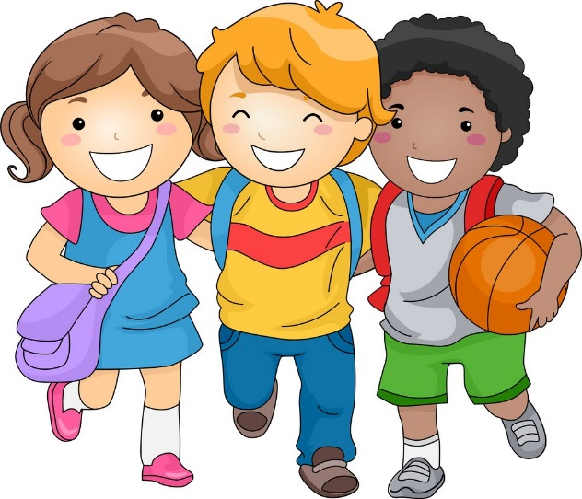

# Number One ClipartWhat does online safety mean?

**Online safety** is about protecting children while they are online.

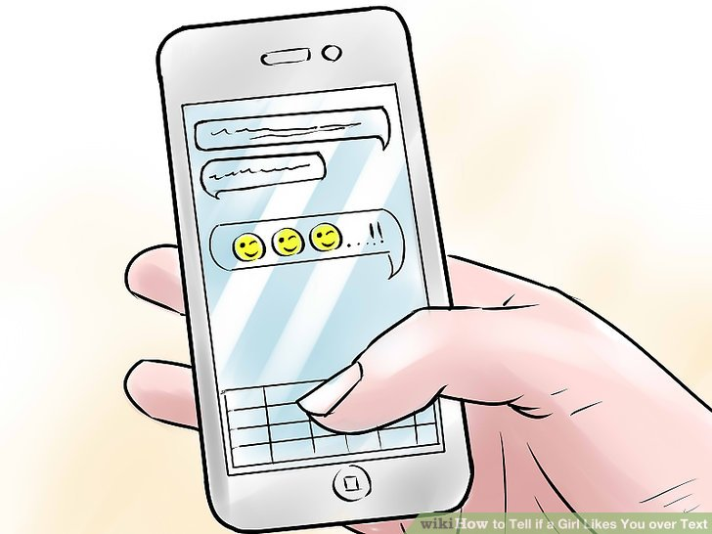**Online safety** is an important part of our curriculum as it helps us to protect and educate you when you are using technology, as well as well as making sure we have tools in place to support you if things go wrong.

Computers and mobile phones help us all to share things and talk to friends or family, but they can also make it easier for bullies and other dangerous people to hurt you or to get close to you. It is important to know how to keep yourself safe on your computer, your phone and on websites.

The school will help if you are sent unkind messages or if someone on the internet has asked you to do anything that has made you feel uncomfortable.

If you are unhappy with any comments or photographs you have seen on your computer or mobile, you can tell a staff member in school.

Follow the **SMART** rules to keep safe online:

**S - SAFE:** Keep safe by being careful not to give out personal information to people, including your full name, address and phone number.

**M - MEETING:** Meeting someone you have only been in touch with online can be dangerous, you should never meet up with someone you have met online.

**A - ACCEPTING:** Accepting emails and instant messages or opening files, pictures or texts from people you don't know or trust can lead to problems and they may contain dangerous viruses. If you are not sure about something you have received, delete it and then find a grown up you trust and tell them.

**R - RELIABLE:** Remember that information you find on the internet may not be true, and that someone you are talking to online may be lying about who they are.

**T - TELL:** Tell your parents or a trusted adult if someone or something makes you feel uncomfortable or worried online. Examples of trusted adults could be your teacher or your headteacher.

# Image result for number 2 clipartOnline dangers

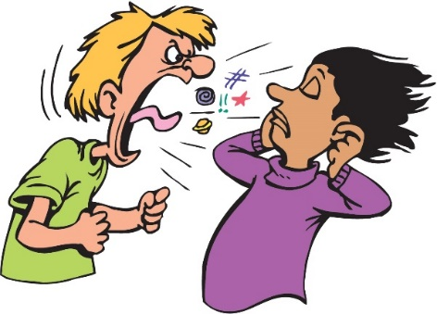The internet is great because you can chat to family, play games and learn new things, but there are some dangers you should be aware of while online. These include:

* Cyberbullying, including receiving nasty text messages and emails.
* People who are lying about who they are so that they can talk to you.
* Looking at online material which is not suitable for children and may upset you.
* Being exposed to computer viruses that can damage devices by opening emails and messages.
* Strangers finding out your personal or private information that you have shared online.
* People who are sharing false or hateful information to try and persuade you to believe something that isn’t true.
* People who are encouraging you to take part in something bad or illegal.

# Cyberbullying

**Cyberbullying** includes any kind of bullying which takes place online; cyberbullies send insulting messages over the internet and sometimes share secret information online to hurt someone’s feelings.

**Cyberbullying** can include the following:

* Sending threatening, scary or upsetting text messages, emails or instant messages
* Sending threatening, private or embarrassing pictures and video clips via mobile phones.
* Making prank phone calls or using someone else’s phone to harass others, to make them think someone else is responsible
* 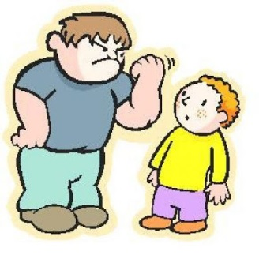Posting private, unpleasant or untrue information about other people to blogs, personal websites and social networking sites

Cyberbullying is not allowed under any circumstances and incidents of cyberbullying will be dealt with quickly by the school.

Cyberbullying is not always done by one person and can often involve a group of people ‘ganging up’ on someone – if you ever see someone being cyberbullied, **never** join in and **always** tell a teacher.

The cyberbully could be one of your peers, an older or younger child or an adult. It is important that you tell someone if you think you are being cyberbullied.

**Sexting**

Sexting is sending **inappropriate pictures, videos or messages** – they can sometimes be called ‘nudes’, ‘nude pics’ or ‘rude pics’, but can also be rude messages.

**Pressuring** someone into sending these pictures, videos and messages is **abuse**.

It is important to know that sharing nude images or videos is **illegal** even if **consent** is given.

**Consent** means that someone has given another person permission to do something.

If consent has not been given for someone to share nude images or videos to another person, it is **abusive.**

It is always illegal to have naked pictures or videos of someone under the age of 18 years old, even if you are not the person sending them and even if you took the photos or videos of yourself.

# Image result for number 5 clipartWho to talk to

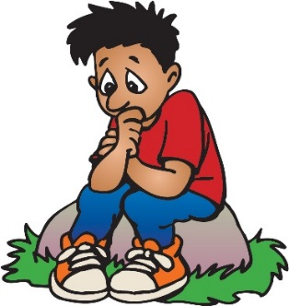If you are worried about something, you can talk to an adult in school. This could be your teacher or any other staff member. We will provide a safe environment for you to learn in as we want to make sure you remain safe, at home as well as in school. **If you need to talk, we will listen.**

We think it is important for you to know where to get help if you are worried or unhappy about something, and we will do our best to spot if there is a problem.

We will always make time to listen and talk if you need us, please remember:

* You are important to us.
* It's never your fault if someone is upsetting you.
* There is always someone that can help you and you will not be in trouble.
* Every child should enjoy the right to a happy and safe childhood, so do not be scared to tell someone if there is anything worrying you.

It’s important that you tell someone you trust if someone is:

* Cyberbullying you.
* Saying things to you online that make you feel upset or uncomfortable.
* Sending unkind messages on the internet or to your phone.
* Asking you to do things that you are uncomfortable with.

People at our school that you can speak to are:

* Mrs Bagnall
* Mrs Goodfellow
* Mrs Scott
* Mr Rammell

If you wish to seek further help, you can call or visit:

* Childline on 0800 11 11 or visit [www.childline.org.uk](http://www.childline.org.uk)
* NSPCC on 0800 800 5000 or visit [www.nspcc.org.uk](http://www.nspcc.org.uk)
* Kidscape on 020 7730 3300 or visit [www.kidscape.org.uk](http://www.kidscape.org.uk)
* Youth Access on 020 8772 9900 or visit [www.youthaccess.org.uk](http://www.youthaccess.org.uk)

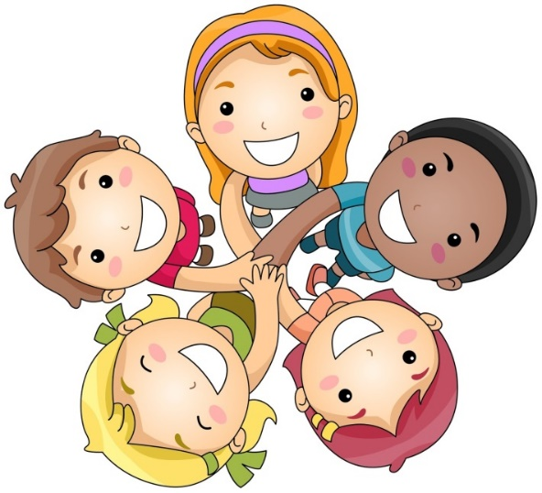**Let’s make Springfields First School a happy place!**